**Oversea QianTai Wechat official account payment guide**

Notes:

Wechat official account is the most complicated payment type in all the payment types. Compares to other payment type, it has a few additional steps to finish the whole process.

Also, when using official payment type, please also see Tencent docs as well.(But Tencent docs is only available in simplified Chinese.)

1. Get parameters from [Wechat official account platform website](https://mp.weixin.qq.com/)：
   1. Get following parameters：
      1. Appid（Application ID）: Begin with “wx”。（开发->基本配置->开发者ID）

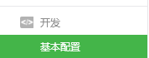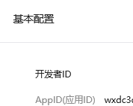

ii.Appsecret(Application secret):A long series of characters, it is only visible to OA admin.



Iii.Website authorization domain name and parameters：

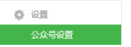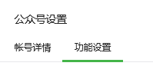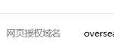

Click”设置”，developer needs upload “MP\_verify” file to merchant server.

b) developer needs provide the following parameters to QFPay technical support：

i.Payment URL(Where to do the payment)

Ii.OA appid,appsecret.

1. Development steps：
2. From appid to get code([Link](https://mp.weixin.qq.com/wiki/17/c0f37d5704f0b64713d5d2c37b468d75.html))

[https://open.weixin.qq.com/connect/oauth2/authorize?appid=APPID&redirect\_uri=REDIRECT\_URI&response\_type=code&scope=SCOPE&state=STATE#wechat\_redirect](https://open.weixin.qq.com/connect/oauth2/authorize?appid=APPID&redirect_uri=REDIRECT_URI&response_type=code&scope=SCOPE&state=STATE" \l "wechat_redirect" \t "https://mp.weixin.qq.com/wiki/17/_blank)

Redirect\_uri:Online shop URL, Use Https to ensure code safety, Using urllib.urlencode（Python）or URLEncoder.*encode(Java) to encode the redirect\_url.*

Scope:Set as snsapi\_base

2.Get code,format like: redirect\_url/?+code=XXX&state=XXX

获取code后，请求以下链接获取access\_token： [https://api.weixin.qq.com/sns/oauth2/access\_token?appid=APPID&secret=SECRET&code=CODE&grant\_type=authorization\_code](https://api.weixin.qq.com/sns/oauth2/access_token?appid=APPID&secret=SECRET&code=CODE&grant_type=authorization_code" \t "https://mp.weixin.qq.com/wiki/17/_blank)

Get openid from JSON response .

1. Change paytype to 800207,fill in “openid” to payment interface “sub\_openid” field.(Note: Do not forget to complete step 4 , otherwise, merchant just opens an order.)
2. In website side, using Tencent interface to invoke the payment([Link](https://pay.weixin.qq.com/wiki/doc/api/external/jsapi.php?chapter=7_7&index=6))

Reference docs：

<https://pay.weixin.qq.com/guide/webbased_payment.shtml>

Notes:

1.Wechat links can only be opened by [Wechat development tool](https://mp.weixin.qq.com/wiki/10/e5f772f4521da17fa0d7304f68b97d7e.html).